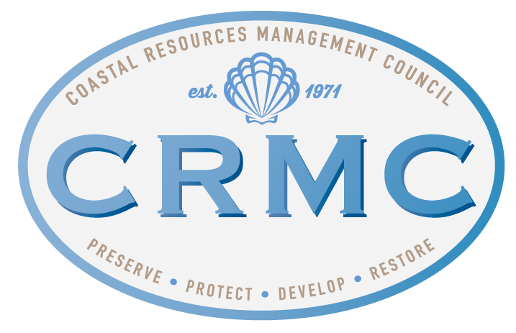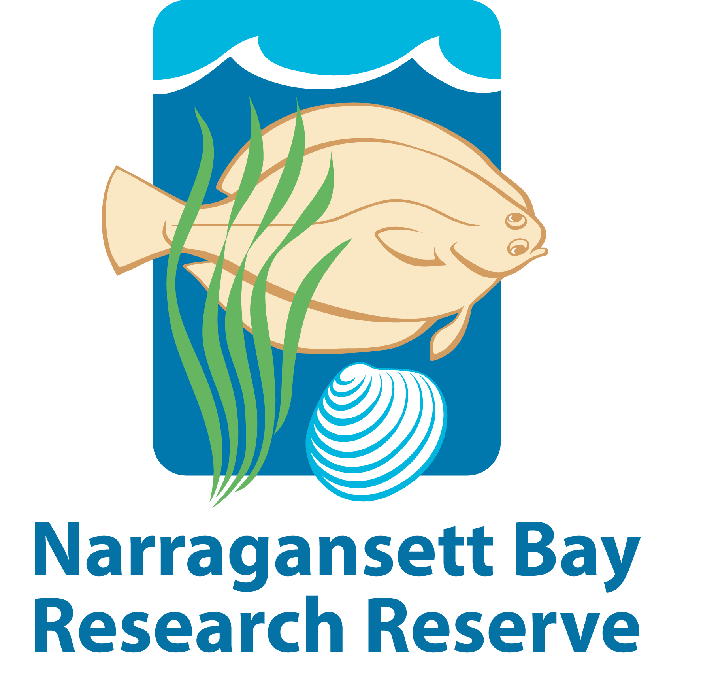

Rhode Island Coastal and Estuary Habitat Restoration Fund
Pre-Proposal Form 2023/2024

- PROJECT SUMMARY

- Project Title :

- Project Location (include map):

- Project type (Planning, Design, Construction, Monitoring and Assessment or Other):

- If other, please specify:

- Habitat type (River System, Salt Marsh, Seagrass Bed, Shellfish Bed, Coastal Upland or Other):

- If other, please specify :

- Total acreage of habitat to be restored :

- □ This is an ongoing project that has previously received funds from the CRMC Coastal and Estuarine Habitat Restoration Fund. If yes, year(s) funding was awarded and amount(s):

- PROJECT MANAGER CONTACT INFORMATION
- Name:

- Organization:

- Address:

- City: 5. State: 6. Zip:

7. Phone: 8. Email:

  - Property Owner(s):

□ The applicant can document ownership of project site or permission to perform all proposed restoration, maintenance, and monitoring activities (Proof of ownership or property owner permission will be required as part of the full project proposal.)

- PRELIMINARY BUDGET

- Amount Requested from Trust Fund:

- Matching Funds (please note sources of match as illustrated below):

Source of Match | Amount | Cash or In-Kind?
(Example) Municipal Restoration Fund | $6,000 | Cash
Total Match Amount: | $6000

3. Total Project Cost:

IV. PROJECT DESCRIPTION (one page maximum)

1. Justification and Purpose
Describe the human impacts and any previous restoration activities at the proposed project site. (Planning project areas may include multiple impacted sites. Please describe the impacts and previous restoration activities at each). Briefly describe the proposed project, its restoration goals, long-term and short-term outcomes. Highlight any direct benefits to traditionally underrepresented and / or underserved communities.

2. Project Activities, Schedule and Work Plan
Describe the planned on-the-ground project activities, and when they are scheduled to occur.

- Coastal Resiliency
Describe how the proposed project addresses or considers resilience to climate change and sea level rise impacts.

AUTHORIZED AGENT OF LEAD ORGANIZATION

_________________________________________________ ___________________________________
Signature Date

Please include the following with your pre-proposal:

□ Map indicating proposed project location

□ Ground-level photograph(s) of existing site conditions

***Note: Letters of support will not be accepted for pre-proposals, but will be considered with full proposals.***

Return completed pre-proposal no later than 4:00 p.m. December 20, 2023 to:

Caitlin Chaffee
Narragansett Bay National Estuarine Research Reserve
RI Department of Environmental Management
235 Promenade St
Providence, RI 02908

caitlin.chaffee@dem.ri.gov

Applicants are required to submit one (1) hard copy and one (1) electronic copy in PDF format.

Contact Caitlin Chaffee at 401-222-4700 xt. 277-4417 with any questions.

